

Spicy Hot Chili served with crackers
Jane’s special recipe from the 1950’s with a hint of jalapeño
Soup of the Day served with cheese toast
Bowl 12 oz bowl Shooter 4 oz bowl
Pint 16 oz cup Quart 32 oz cup

SOUP AND CHILI
SUBS - WRAPS - WICHES - CROISSANTS
HOT OPTIONS:
Ham or Turkey Bacon Cheese
With bacon, American cheese and honey mustard
Turkey Bacon Ranch
With Swiss cheese, lettuce, and tomato
Chicken Bacon Ranch
With Swiss cheese, lettuce, and tomato
Chicken Bacon Spinach
With ranch
Chicken Strip – Grilled
With lettuce, tomato, Miracle Whip, and Lic’s house dressing
Pepper Jack Chicken
With pepper jack cheese, onions, and green peppers
Cuban
With ham, turkey, shredded cheddar jack cheese, pickles, and Lic’s buttermustard sauce
Reuben
With corned beef, sauerkraut, Swiss cheese, and Lic’s reuben sauce

COLD OPTIONS:
Gourmet Sub
With turkey, ham, corned beef, American, Swiss, lettuce, tomato, and Lic’s house dressing
White Meat Chicken Salad
With lettuce
Buffalo Chicken Salad
With hot sauce and lettuce
Mandarin Chicken Salad
With oranges, nuts, and lettuce
Deli & Swiss
Choice of meat with Swiss cheese, lettuce, tomato, and Lic’s buttermustard
BLT
With bacon, lettuce, tomato, and Miracle Whip
Veggie
With carrots, green peppers, lettuce, tomato, and Lic’s house dressing
Tuna Salad
With lettuce

Grilled Cheese (American, Swiss, or pepper jack)
Grilled Three Cheese
With American, Swiss, and pepper jack cheese
Tuna Melt
With American cheese
Deli Melt w/Swiss cheese
Your choice of turkey, ham, or corned beef
Steakburger
1/3 lb. USDA Angus burger – comes with lettuce and tomato
Double Steakburger
With lettuce and tomato

MELTS & BURGERS

Small 16 oz Medium 24 oz Large 32 oz

Sweet/Unsweet Tea, Hot Chocolate, Milk
Bottle Drinks Red Bull, Root beer, Water
Add Syrup Cherry, Vanilla, or Chocolate
DRINKS

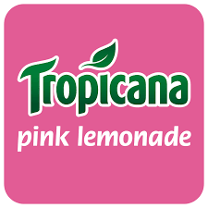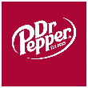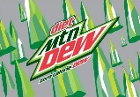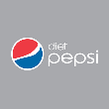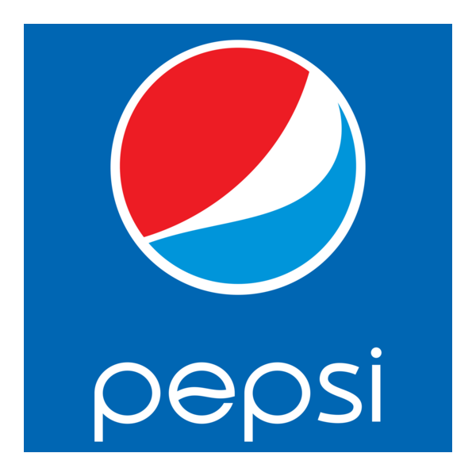

QUESADILLAS
Spicy Ranch Chicken Quesadilla
With chicken, cheddar jack cheese, ranch, and hot sauce
Spicy Ranch Cheese Quesadilla
With cheddar jack cheese, ranch, and hot sauce

SIDES
*Chips are included with any sandwich purchase. Apple, banana, or mandarin oranges may be substituted for no charge. All other substitutions will result in an upcharge.*
Lay’s Original Chips
Apple, Banana, Mandarin Oranges
Pasta Salad
Fruit Cup
BBQ Grippos or Cheddar Sunchips
Side Salad with cheese toast
Grilled Broccoli
Soup/Chili Shooter

DOUBLE DECK CLUB
Three slices of bread with ham, turkey, American cheese, Swiss cheese, bacon, lettuce, tomato, and Lic’s buttermustard

LIC’S KID’S MEALS
Served with chips, drink, gummy worm, and prize.
Prize not recommended for kids under 3.
Grilled Cheese
Cheese Quesadilla served plain – just cheese

BREAD CHOICES
Sub Buns Frenchette, multigrain, pumpernickel – all grilled with butter
Honey Wheat Wrap grilled
Croissant made with all butter
White Bread fresh baked
Wheat Bread multigrain

Served with Cheese Toast or in a Honey Wheat Wrap
Dressings: Lic’s House (sweet Italian), Honey Mustard, Ranch
Chef Salad
Chopped lettuce, turkey, ham, cheddar jack cheese, tomatoes, green peppers, carrots, hard-boiled eggs
Spinach Salad with Lic’s House Dressing
Spinach, mandarin oranges, hard-boiled eggs, bacon, mixed pecans/cashews
Apple Praline Salad with Honey Mustard
Chopped lettuce, cheddar jack cheese, green peppers, carrots, praline pecans, and apple slices

CHOPPED SALADS

LIC’S HOMEMADE SAUCES
Lic’s House Dressing Sweet Italian
Lic’s Buttermustard Sauce Butter, mustard, dried onion, and poppy seeds
Lic’s Reuben Sauce Mustard, horseradish, and miracle whip

